
IP 02-03-59 Version 1

Standard Site Establishment Document

DATE

Overview
This list is not exhaustive but as a minimum the following elements should be considered ahead of a new site set up.

- Site Layout
- Site Office & Meeting Rooms
- Site Office Notice Board
- Toilet Facilities
- Canteen Facilities
- Changing Facilities
- Site Storage
- Waste Management
- Site Access, Egress & Parking
- Fencing & Signage
- Smoking/Vaping Shelter

Site Layout

Early consideration of site services (either existing or required) will inform general site layout;
  - Power supply
  - Foul drainage
  - Cold water supply
  - Broadband
  - Existing access points
  - Parking

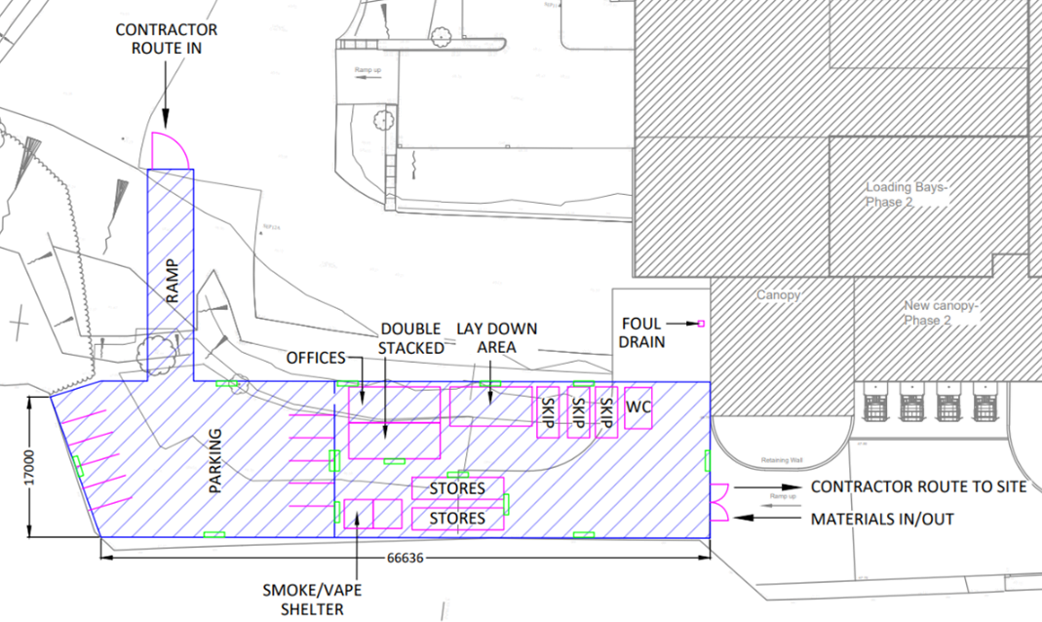
Example Site Layout

Site Offices & Meeting Rooms
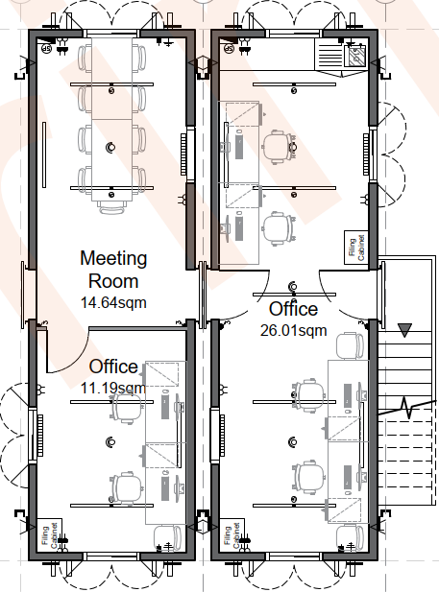
Site Offices and Meeting Rooms can be hired from suppliers. All to be regularly cleaned and maintained.
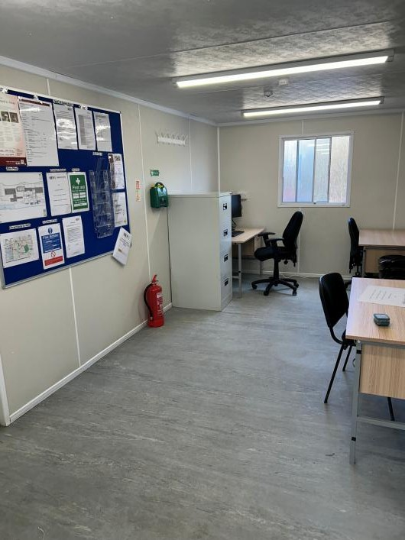
An example set up is shown below and right, however these can be tailored by the supplier to the project requirements and can be ordered to include kitchen facilities, filing cabinets, whiteboard, notice boards, tables and chairs etc.

Mandatory items:
- Fridge
- Microwave
- Toaster
- Kettle
- Washing up liquid
- Mugs
- Tea / coffee etc.
- Cutlery
- TV/monitor for meetings
- Video conference camera
- Computer screens
- Drawing rack & clamps
- Key lock box
- Extra PPE
- Site file (with extra lever arch files)
- Health & Safety poster
- Health & Safety policy statement
- Insurance document
- Notice board
- Printer / photo copier
- Stationary (pens, paper, tape etc.)
- Waste bins
- Fire extinguishers
- Fire blanket
- First aid kit
- Extension leads
- Wifi router
- Sign in register

Site Office Notice Board

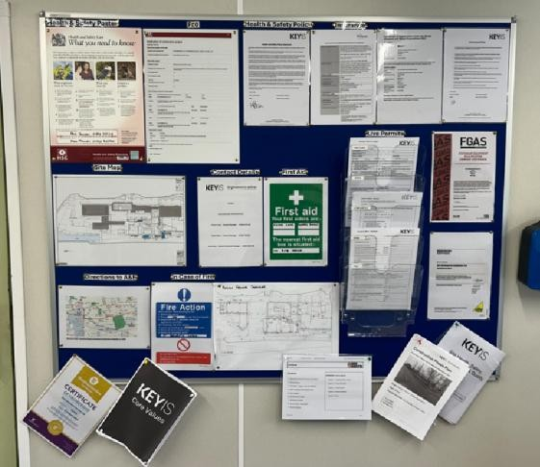
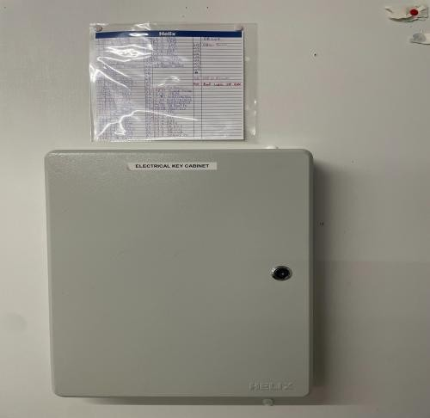
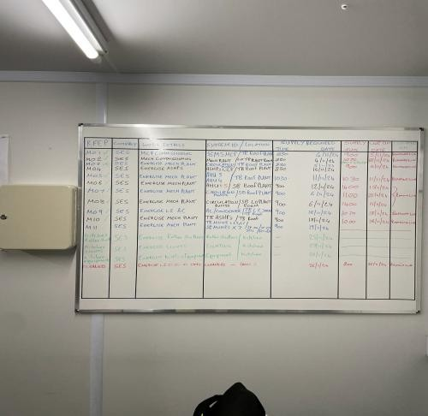
A notice board should be clearly on display within the site office containing the following information.
Mandatory items:
  - Health & Safety Poster
  - F10 Notice
  - Health & Safety Policy
  - Insurance Policy
  - Site Map
  - Contact Details
  - First Aiders
  - Direction to nearest A&E
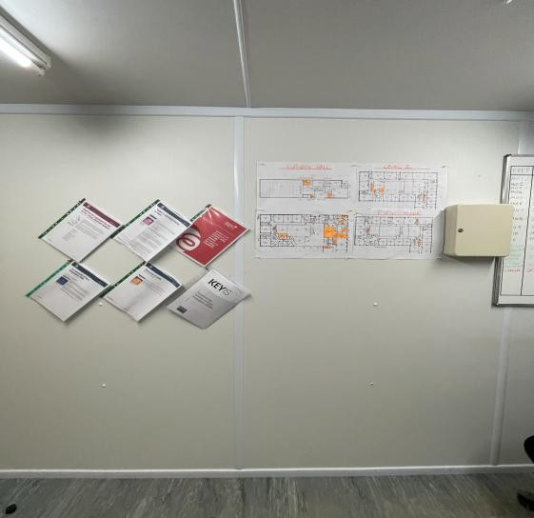
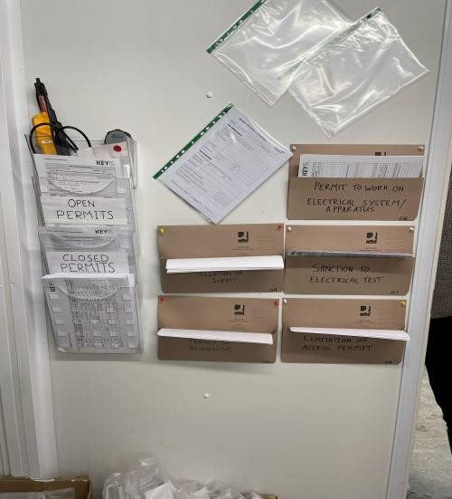
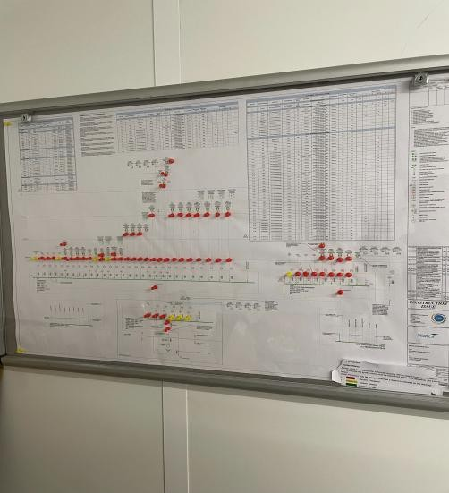
  - Muster point location in case of Fire and Emergency
  - Electrical testing certificate for site set up
  - Electrical Key Cabinet
  - Electrical circuit noticeboard
  - Electrical procedures and permits

You may want to display other important information in this location such as live permits, certificates, policies, etc.

Toilet Facilities
Toilet Facilities can be hired from suppliers. These can come as a combined Male and Female unit or separate if required. To be regularly cleaned and maintained.
Table 1
Number of facilities needed per number of people at work
Number of people  at work | Number of Cubicles | Number of  Washbasins
1 to 5 | 1 | 1
6 to 25 | 2 | 2
26 to 50 | 3 | 3
51 to 75 | 4 | 4
76 to 100 | 5 | 5

Location of toilets need to be considered as a foul drainage, power supply and cold water supply will need to be provided to the cabins.

The tables to the right are taken from CDM Regulations can be used to select the size and type of toilet facilities that will be required.
Table 2
May be followed as an alternative to column 2 of Table 1 if toilets are only used by men. A urinal may either be an individual urinal or a section of urinal space which is at least
60mm long.
Number of men at work | Number of Cubicles | Number of Urinals
1 to 15 | 1 | 1
16 to 30 | 2 | 1
31 to 45 | 2 | 2
45 to 60 | 3 | 2
61 to 75 | 3 | 3
76 to 90 | 4 | 3
91 to 100 | 4 | 4

Items to include:
- Toilet rolls
- Blue paper towels
- Hand soap
- Toilet brushes
- Waste bin
- Toilet cleaner (bleach)
- Air freshener
- Fire extinguishers
- Visiting cleaner

Canteen Facilities
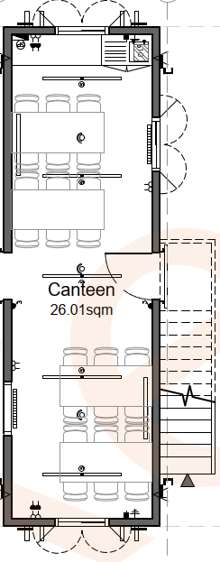
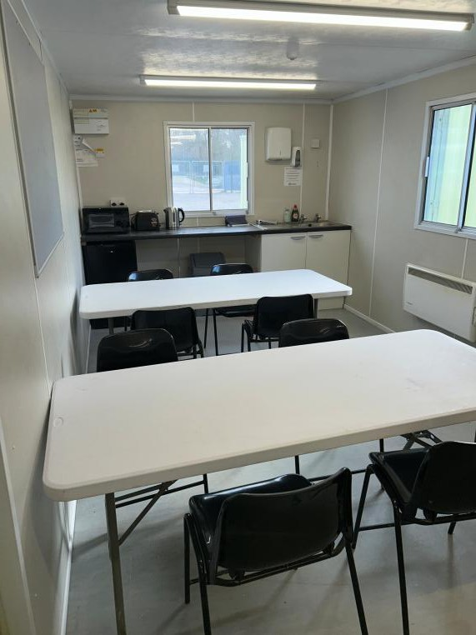
Canteen Facilities with sink, tables and chairs included as per the drawing on the left can be hired from suppliers. Suitable and sufficient seating should be provided for the peak number of operatives foreseen to be on site during the project. To be regularly cleaned and maintained.

Location of Cabins need to be considered as foul drainage, power supply and cold-water supply will need to be provided to the cabins.

Consumables items:
- Fridge
- Microwave
- Kettle
- Toaster
- Blue paper towels
- Waste bin
- Mugs
- Cutlery
- Fire extinguishers
- Notice board

Note that all electrical appliances will require PAT Testing even when purchased from new.

Changing Facilities

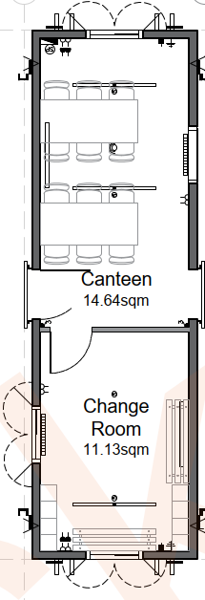
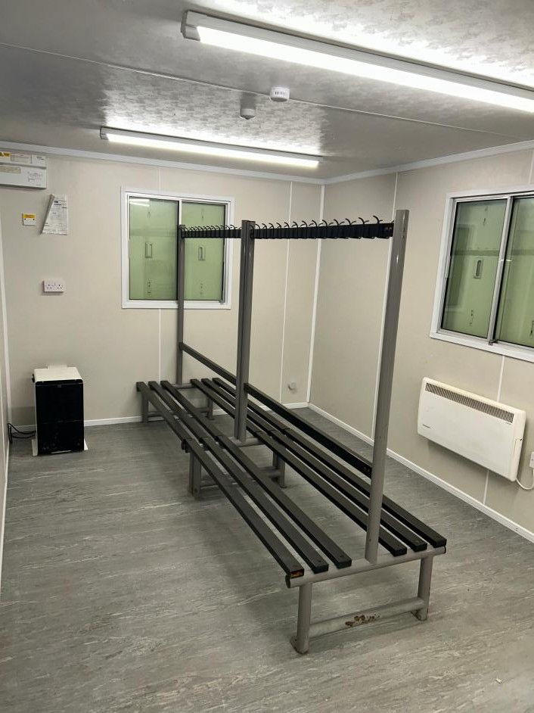
Change facilities with benches, hooks and heaters included as per the drawing on the left can be hired from suppliers.

Suitable and sufficient hooks and changing area should be provided for
the peak number of operatives foreseen to be on site during the project.

Location of Cabins need to be considered as a power supply will need to be provided.

Site Storage
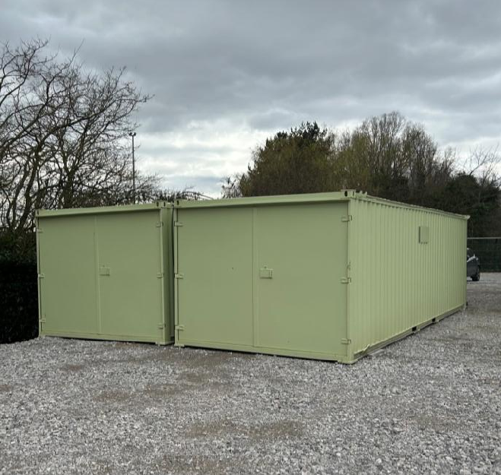
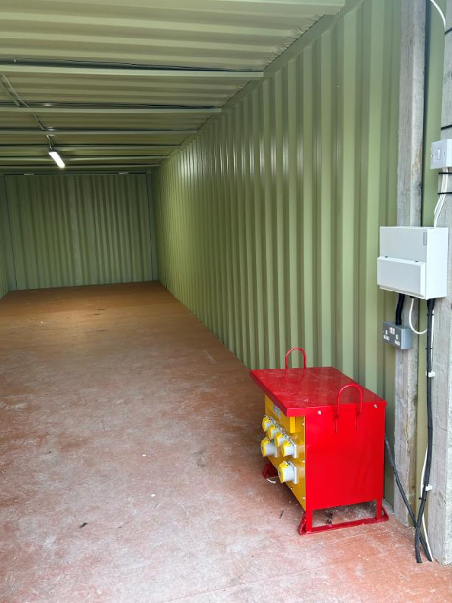
Material storage containers can be hired from suppliers.

Location of the storage containers is to be considered to allow for delivery vehicles and distribution of materials to site in a safe manner.

Suitable and sufficient storage should be provided and separate containers for different trades where necessary, some of which may require racking or pigeonholes.

Separate COSHH cabinets along with register may also be required to store consumables on site.

Power and lighting may be required within stores which can be installed post delivery to site. This should be taken into consideration when looking at positioning of the cabins.

Lay down areas for plant and materials that can be stored
externally should also be considered.

Waste Management
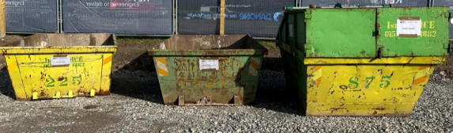
Waste management may be required if not provided by the client, this can be hired from companies such as X-Hire who can provide a quote based on the anticipated number of skips and changes required throughout the project.

Different types skips may be required at different period throughout the project depending on the waste being produced and all waste should be segregated where possible into the necessary clearly labelled skips.

Enclosed skips for general waste are a good idea to remove the problem of loose rubbish blowing through the compound or being picked up by vermin.

Site Access, Egress & Parking
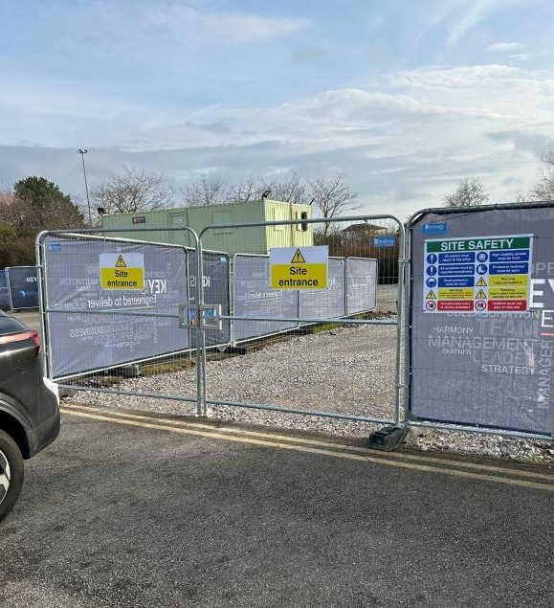
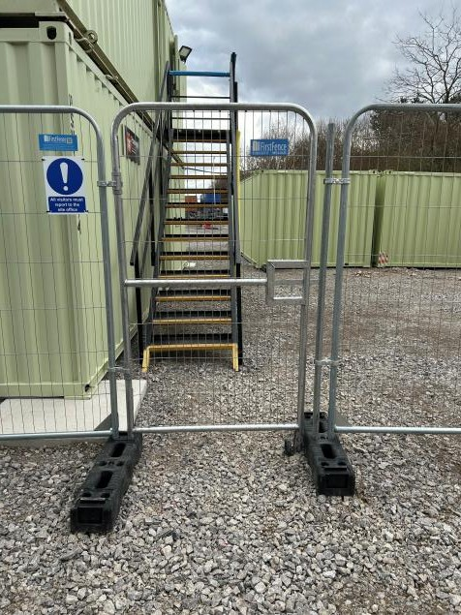
Site Access for contractor parking, compound access and site access will be required. These should be clearly marked with signa

Different routes for material deliveries may be required. If possible, a parking, system should be utilized to avoid vehicles having to turn around.

Segregated routes for pedestrians and vehicles should be used where possible.

If it is a requirement by the client to provide our own parking, then this area should be segregated using barriers or fencing.

Fencing & Signage
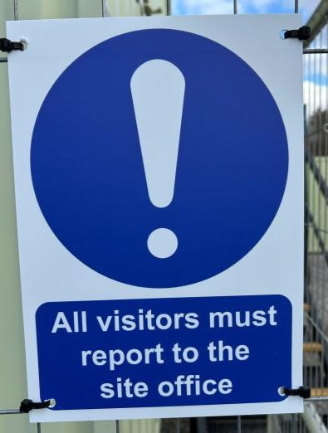
Fencing and Signage is required to secure the compound and segregate areas.
Insert image

This can be purchased from First Fence if required for a long duration or hired from Speedy or X-Hire etc.

COMPANY NAME mesh can be purchased and fitted to the fencing via cable ties which could also incorporate the client's information (this may be contractually required).

Signage highlighting routes, site entrances, PPE requirements and contact details etc. are required.
Insert image

Insert image

Smoking and Vaping Shelter

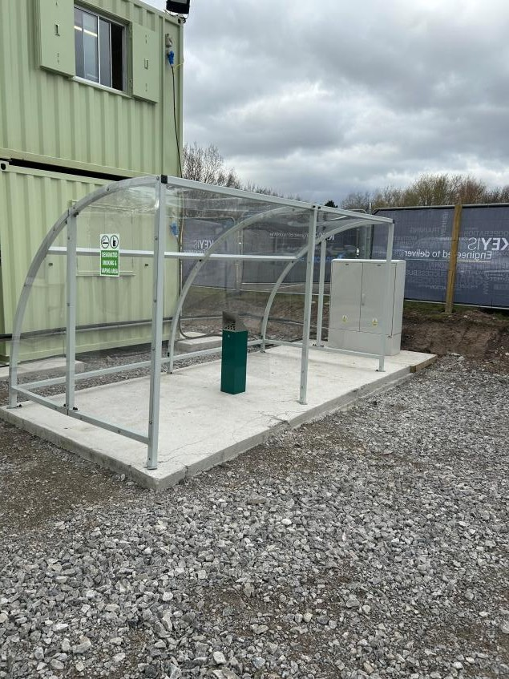
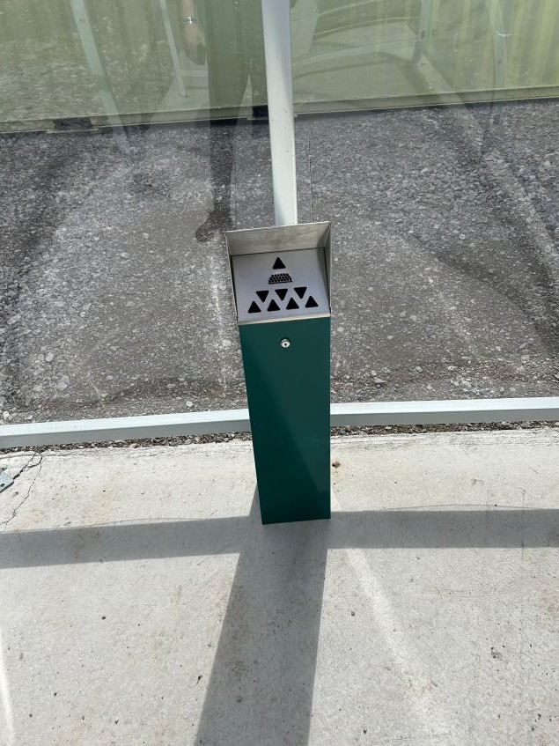
Depending on the clients site rules. A smoking area may be required including segregation for smoking and vaping, this is to be clearly signed.

Location of this is to be considered as this should not be within any work areas and may also need to be agreed and approved by the client.

